# **CHAPTER FOUR**

# **RESULTS AND DISCUSSION**

## 4.0 INTRODUCTION

Software documentation is a written text that accompanies computer software. It explains how the software operates and how to use the system. Types of documentation include:

**User** documentation, it is intended to help the users of the system, it explains how to start / stop the system, how to use the features of the system. The users are usually **non-technical** people such as students and supervisors, who don't need to know how the system works. They just need to know **how to use it**.

The technical documentation is intended to help the **maintainers** of the system (the people who need to keep the system running smoothly, fix problems, etc.). The maintainers are usually **technical** people, who need to know exactly **how the system works**. In this system, they are the project coordinators.

**4.1 Features of the system**

**4.1.1 Login page**

The login provides a mechanism for authenticating the user in the system, user has to login with his username and password before gaining access to the system



Figure 4.1: login page

**4.1.2 Signup page**

A registration form is a list of fields that a user will input data into and submit in order to be part of the system



Figure 4.2: signup page

**4.1.3: Questionnaire list**

Shows the list of questionnaires for a particular user

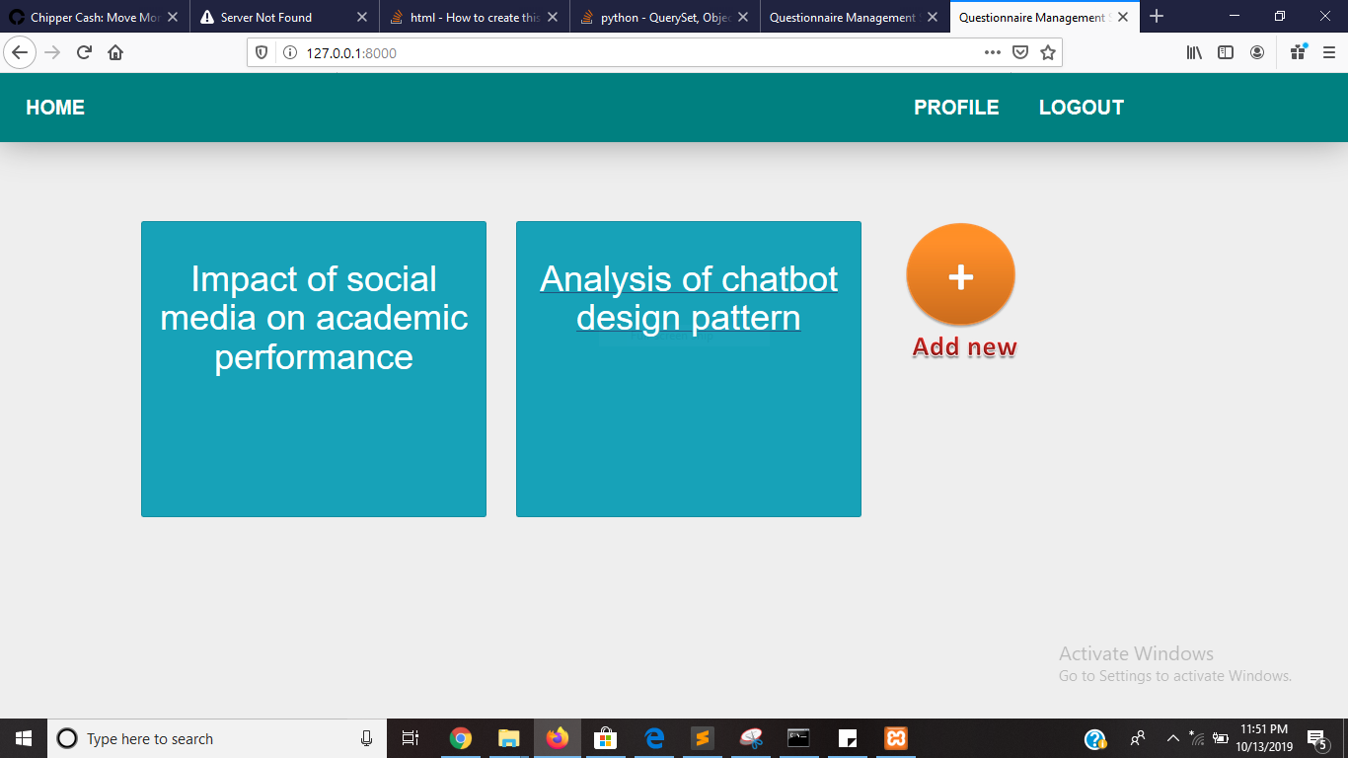

Figure 4.3: questionnaire list

**4.1.4: questionnaire form**

Form which is used in creating a new questionnaire

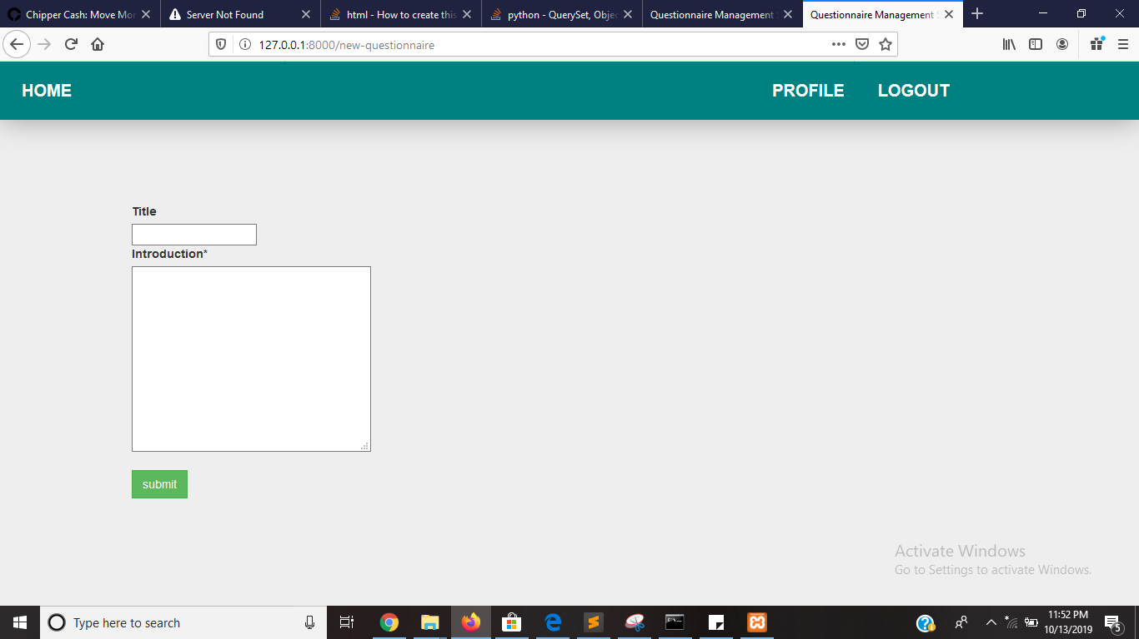

Figure 4.4: questionnaire form

**4.1.5 Questionnaire Detail**

This shows all the properties of the questionnaire including the form for adding a new question

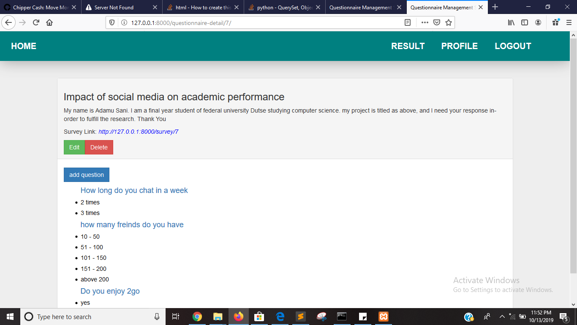

Figure 4.5: questionnaire detail

**4.1.6: Question form**

Form used in creating a question for a particular questionnaire

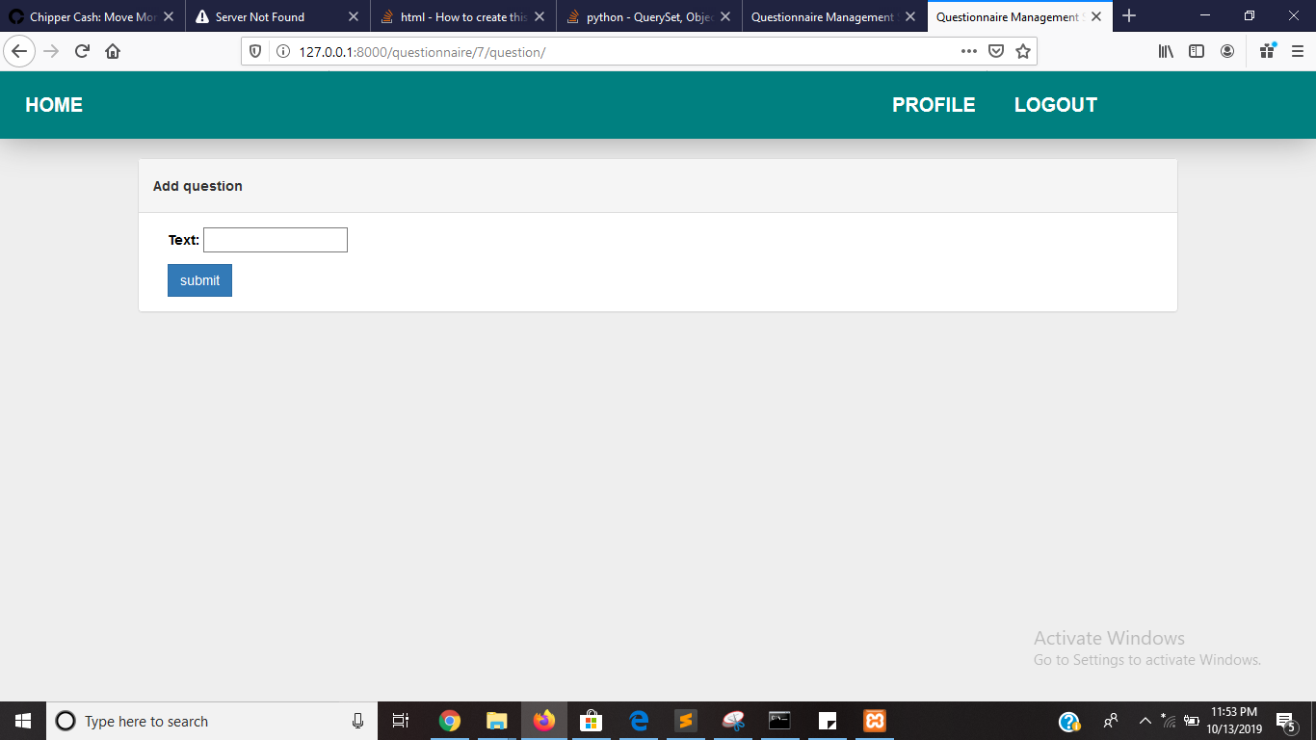

**Figure 4.6: question form**

4.1.7 Question detail

Shows all the properties of the question including the button for adding options to the question

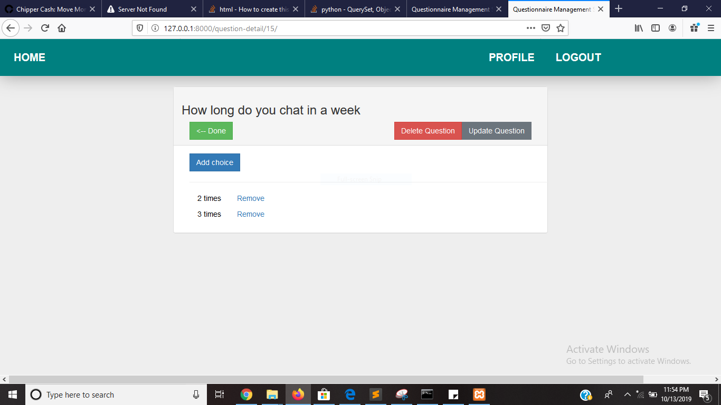

4.7: question detail

**4.1.8 Choice Form**

Use for adding a choice or an option to a particular question of a questionnaire

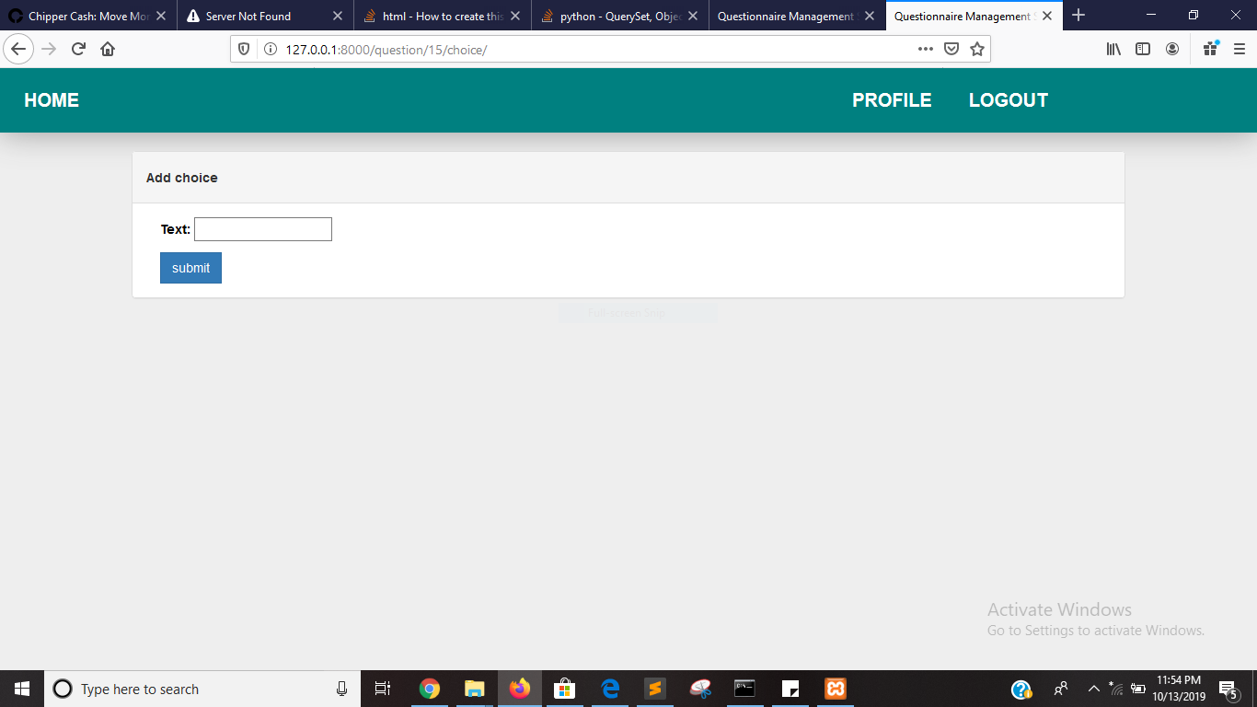

Figure 4.8: choice form

4.1.9 Questionnaire Introduction

What a respondent will first see when trying to fill a questionnaire which contains the questionnaire title and a little introduction about the research

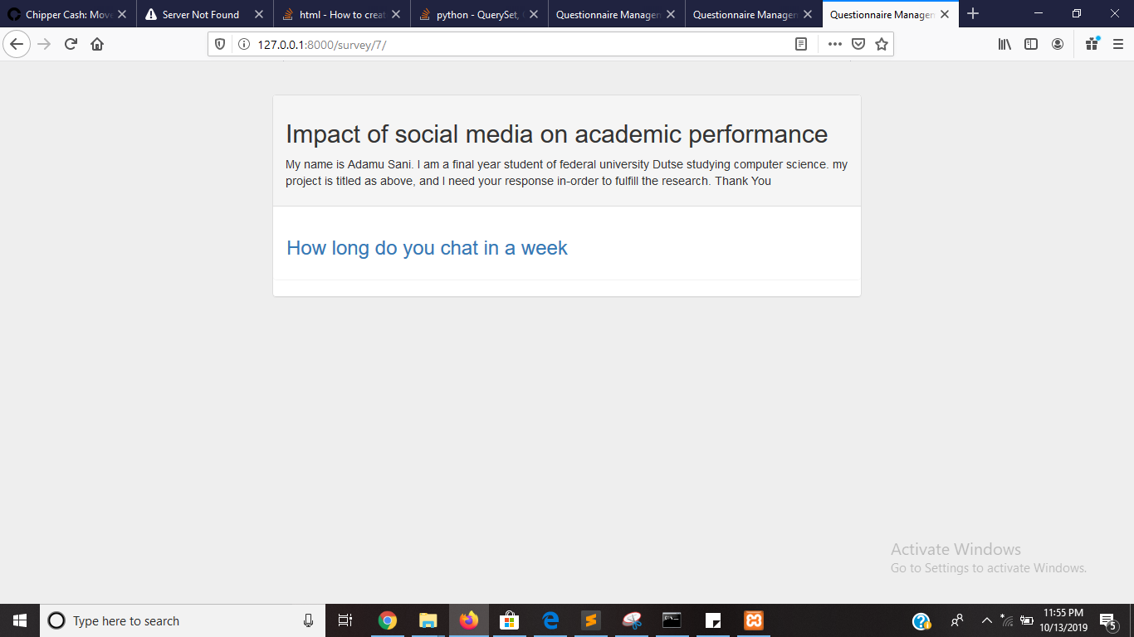

4.9 questionnaire introduction

4.1.10 questionnaire response form

The form that is used by respondents for filling the questionnaire

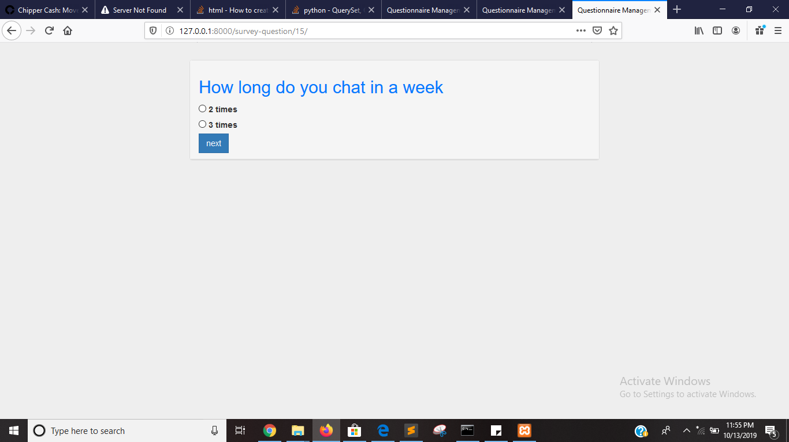

Figure 4.10: questionnaire response form

4.11 Thank you page

The page that shows appreciation after a user have finish filling a questionnaire



Figure 4.11: thank you page

4.12 Result

Gives the statistical analysis of all the response collected, with quantity and percentages

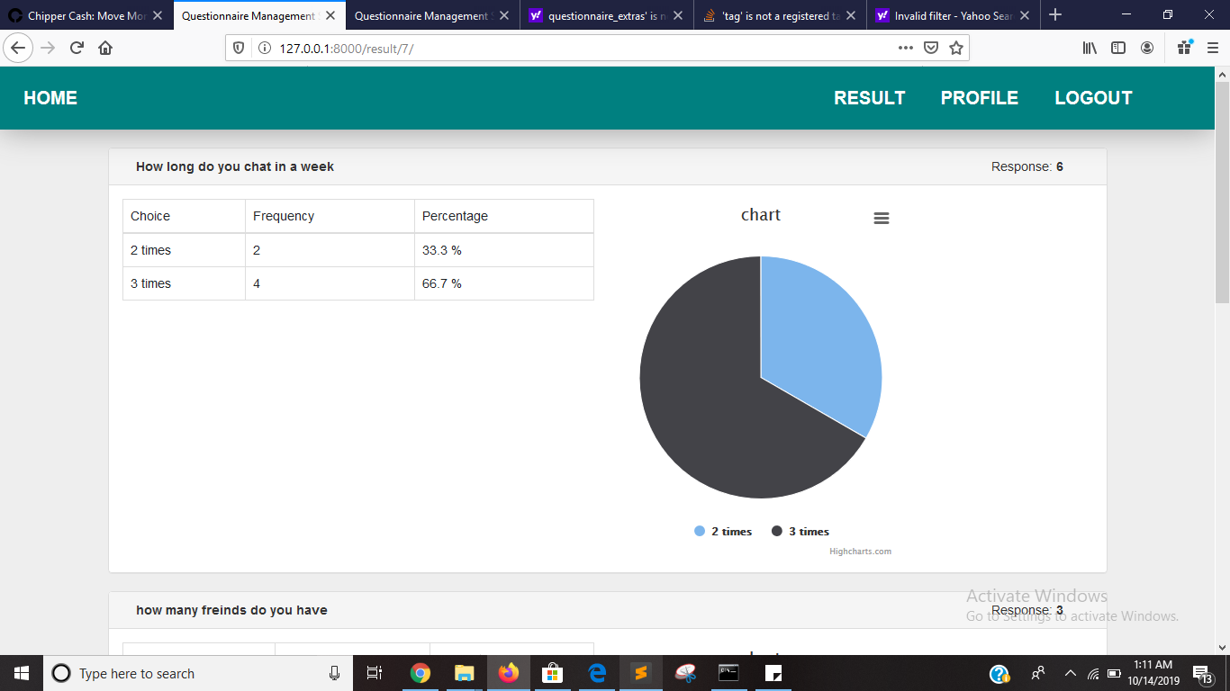

Figure 4.12: result

**4.2 Limitations of the system**

1. Doesn’t support open ended questions
2. Doesn’t support locational data